11 September 2003

Disability Rights Unit
Human Rights and Equal Opportunity Commission
GPO Box 5218
SYDNEY NSW 2001

Dear Sir/Madam

Submission in response to the HREOC Discussion Paper: Assistance Animals under the Disability Discrimination Act

In response to the call for comments on the proposed amendments to the Disability Discrimination Act, Guide Dogs Victoria would like to draw your attention to the submission made by Blind Citizens Australia (BCA). Guide Dogs Victoria fully supports the recommendations contained in their submission.

In particular, we support their calls to:

- Amend the Disability Discrimination Act in relation to the definition of a “trained” assistance animal. The term “trained” should only be satisfied when:

- the animal is trained by an accredited organisation; and

- the person is trained to use the animal by an accredited organisation;

- all training is given by an accredited instructor; and

- the training the animal has received is relevant to the user’s need for the assistance animal; and

- the user’s need for the assistance animal relates to his or her disability.

We believe that this would maintain a sufficiently high standard amongst assistance animals to ensure that the generally high esteem that Guide Dogs are held in is not diminished. Guide Dog organisations already receive accreditation through the International Guide Dog Federation.

- Incorporate something more than companionship and increased self-confidence in the term “trained to alleviate the effects of disability”.

- 2 -

- Reject the option of prescribing State and Territory health and hygiene laws under s.47(3) of the DDA.

- Instigate an education campaign explaining the rights users of Guide Dogs, hearing dogs or other assistance animals are entitled to. Guide Dogs Victoria also receives numerous complaints about refusals of access based simply on the fact that a person is accompanied by a Guide Dog. An education campaign would go a long way toward reducing these incidents that cause inconvenience and sometimes endanger the lives of blind or vision impaired Guide Dog handlers.

We would welcome the opportunity for further discussion on this important issue.

Yours sincerely
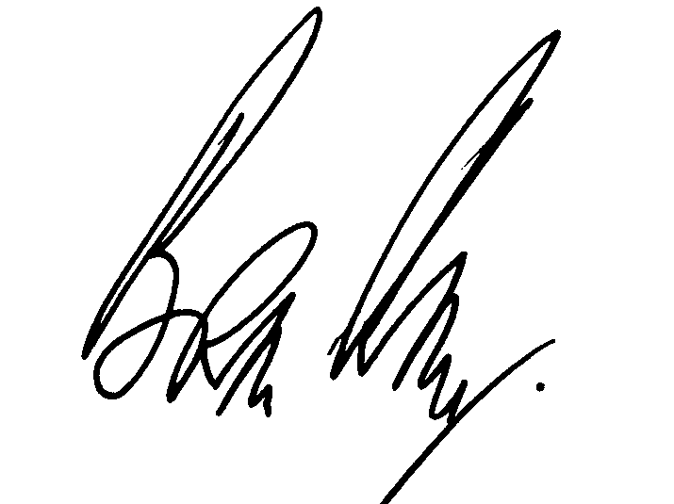
Brian Ritter
Chief Executive Officer

