## 

## Communique

## 11-12 November 2019

The Australian and New Zealand Children’s Commissioners and Guardians (ANZCCG) met in Brisbane on 11-12 November 2019.

The ANZCCG aims to promote and protect the safety, wellbeing and rights of children and young people in Australia and New Zealand. The ANZCCG:

* promotes the rights of children and young people, including their right to participate in decisions relating to them, as articulated in the United Nations *Convention on the Rights of the Child*
* ensures the best interests of children are considered in the development of policies and programs
* gives voice to the views of, and encourages direct consultation with, children and young people on matters that affect them
* encourages systemic improvement, informed by evidence-based research, in areas that impact on the rights, interests and wellbeing of children and young people.

Over the course of the meeting, members exchanged information on work underway in each jurisdiction. The meeting focused on the six priority areas:

1. **Achieving better outcomes for Aboriginal and Torres Strait Islander and Māori children and young people**

**We reaffirm our commitment to advocate toward the appointment of Aboriginal, Torres Strait Islander and Māori commissioners for children and young people in all jurisdictions.**

ANZCCG members acknowledge the position paper, *Establishment of a national commissioner for Aboriginal and Torres Strait Islander children and young people*, released by SNAICC and Family Matters in October 2019.

Members reaffirm the importance of Aboriginal and Torres Strait Islander and Māori leadership and self-determination of First Nation peoples in achieving improved outcomes for their children and young people. Members will continue to advocate towards the appointment of Aboriginal, Torres Strait Islander and Māori Children and Young People Commissioners.

1. **Promoting young people’s engagement and participation**

**We need to make sure children’s voices are promoted and considered in policy and practice**

ANZCCG members acknowledge the report of the United Nations Committee on the Rights of the Child (the UN Committee), *Concluding observations on the combined fifth and sixth periodic reports of Australia*, released on 1 November 2019.

In September 2019, the UN Committee heard from Dujuan, a 12-year-old Arrente/Garrwa boy from central Australia, whose experience in the youth justice system was captured in the film *In My Blood It Runs*.

We advocate for national and international bodies to create opportunities to listen to the voices of children and young people and involve them in decision-making.

**We continue to support the rights of LGBTIQ+ children and young people to have a voice in decision-making**

ANZCCG members support the rights of LGBTIQ+ children and young people to be counted and have a say in decision-making. ANZCCG members will advocate for gender diversity to be appropriately considered in the 2021 Australian Census.

1. **Upholding the rights of children and young people in contact with the youth justice system**

**We need to raise the minimum age of criminal responsibility and increase investment in diversionary supports**

Currently, the minimum age of criminal responsibility across Australia and New Zealand is 10.

The ANZCCG acknowledges recent recommendations by the UN Committee to raise the minimum age of criminal responsibility and the work of the Australian Council of Attorneys-General, which has established a working group to review the matter.

The ANZCCG recommends the age of criminal responsibility should be raised to at least 14 years, in line with the UN Committee recommendation. ANZCCG members will continue to advocate for this reform.

1. **Improving the safety of children and young people in organisations**

**We have an ongoing commitment to implementing the recommendations of the Royal Commission into Institutional Responses to Child Sexual Abuse**

ANZCCG members continue to monitor progress in implementing the recommendations of the Royal Commission into Institutional Responses to Child Sexual Abuse, including work to implement nationally-consistent child safe standards and reportable conduct schemes.

1. **Ending violence against children and young people**

**We must improve online safety for children and young people**

ANZCCG members note the establishment of the Australian Centre to Counter Child Exploitation, providing a coordinated response to prevent and address child exploitation.

Technology provides great opportunities for children and young people, along with some new risks. It is important to educate the community on emerging technologies to promote safe online engagement for children and young people.

**Support for the Royal Commission into Violence, Abuse, Neglect and Exploitation of People with Disability**

The ANZCCG welcomes the establishment of the Royal Commission into Violence, Abuse, Neglect and Exploitation of People with Disability and commends its stated commitment to examining and supporting the rights of children and young people with disability.

In particular, ANZCCG members support ongoing efforts by the Royal Commission to hear from children and young people in culturally-safe and trauma-informed ways, including children and young people who experience difficulties with communication.

ANZCCG members will promote the voices of children and young people in submissions to the Royal Commission.

1. **Promoting children and young people’s safety and wellbeing**

**Monitoring the National Disability Insurance Scheme**

Australian members discussed the challenges faced by children and young people who need support from both the National Disability Insurance Scheme, and state and territory-based child protection services. The ANZCCG will continue to monitor this area to keep up-to-date with developments.

**Children in immigration detention**

ANZCCG members noted concerns about the rights and wellbeing of children in immigration detention, including community detention,. The ANZCCG will continue to monitor developments in this area and advocate for children’s rights to be protected.

**Child poverty**

ANZCCG members note the significant impact of poverty on a child’s life outcomes. The Australian Council of Social Service (ACOSS) has [calculated](https://www.acoss.org.au/wp-content/uploads/2018/10/ACOSS_Poverty-in-Australia-Report_Web-Final.pdf) that around 17 per cent of children in Australia live in poverty. The Telethon Kids Institute CoLab has [released research](https://colab.telethonkids.org.au/resources/impact-of-poverty/) revealing children growing up in poverty can experience developmental delays that affect their future academic success and prospects as an adult, with poverty in the first five years of a child’s life particularly harmful to their development.

The ANZCCG will continue its advocacy to seek solutions to child poverty across Australia and New Zealand, which underpins our work to support the rights, safety and wellbeing of children and young people.

ANZCCG members thank the following organisations and their representatives who presented at the meeting:

* Derek Oram Sandy, Yerongpan Aboriginal Corporation, for welcoming them to Country
* Gavin Bannerman, Director, Queensland Memory, State Library of Queensland
* Federal Agent Stephen Jay, Operations Manager, Australian Centre to Counter Child Exploitation
* The Hon Roslyn Atkinson AO, Commissioner, Royal Commission into Violence, Abuse, Neglect and Exploitation of People with Disability
* Joel Clark, Advocacy and Government Relations Adviser, Amnesty International.

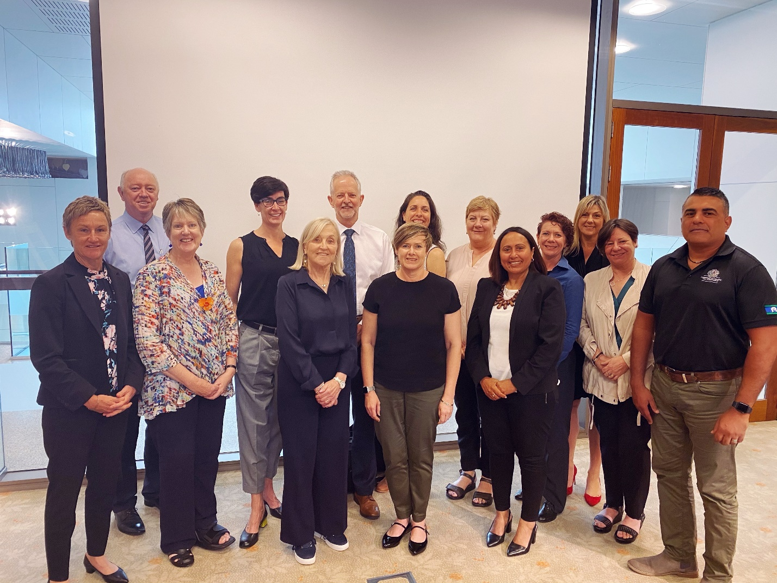

**ANZCCG members from left to right –**

**Colleen Gwynne (NT), Colin Pettit (WA), Penny Wright (SA), Liana Buchanan (Vic), Cheryl Vardon (Qld), Judge Andrew Becroft (NZ), Janet Schorer (NSW), Leanne McLean (Tas), Helen Connolly (SA), April Lawrie (SA), Jodie Griffiths-Cook (ACT), Natalie Siegel-Brown (Qld), Megan Mitchell (Australia), Justin Mohamed (Vic)**